Data Sheet
Product Information
Product Name | : | Recombinant human Growth Hormone (rhGH)
Synonyms | : | GH, GH-N, Somatotropin, Growth Hormone 1
Description | : | Growth hormone (GH), also known as somatotropin, is a peptide hormone that stimulates growth, cell reproduction, and cell regeneration in humans and other animals. It is thus important in human development. It is a type of mitogen which is specific only to certain kinds of cells. Growth hormone is a 191-amino acid, single-chain polypeptide that is synthesized, stored, and secreted by somatotropic cells within the lateral wings of the anterior pituitary gland.  GH is a stress hormone that raises the concentration of glucose and free fatty acids. It also stimulates production of IGF-1. (Ref. From Wikipedia)
NCBI Accession No. |  | NM_000515.4
Amino acid sequence | : | MFPTIPLSRLFDNAMLRAHRLHQLAFDTYQEFEEAYIPKEQKYSFLQNPQTSLCFSESIPTPSNREETQQKSNLELLRISLLLIQSWLEPVQFLRSVFANSLVYGASDSNVYDLLKDLEEGIQTLMGRLEDGSPRTGQIFKQTYSKFDTNSHNDDALLKNYGLLYCFRKDMDKVETFLRIVQCRSVEGSCGF*
Molecular Mass | : | 22.3 kDa (192 aa)
Protein Tags | : | No tagging
Source | : | E. coli.
Cat. No. | : | JW-H022-0010, JW-H022-0025, JW-H022-0100, JW-H022-0250, JW-H022-0500, JW-H022-1000
Storage | : | Should be at ≤ -70 ℃ as undiluted aliquots of handy size. Avoid repeated freezing and thawing.
Cross Reactivity | : | Rat

Quality Control
Test items |  |  |  | Specifications
Appearance |  |  | : |  | Clear, colorless liquid
Purity |  |  | : |  | Greater than 95 % by SDS-PAGE
Specificity |  |  | : |  | Using Western blot, detection | 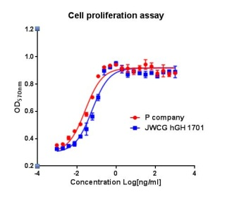
Concentration |  |  | : |  | 0.1 mg/㎖, Bradford method
Biological Activity |  |  | : |  | Determined by proliferation of Nb2-11 indicator cells.  The ED50 is ≤ 0.05 ng/ml, corresponding to a specific activity of > 2.0 × 10⁷ U/mg
Endotoxin |  |  | : |  | Less than 0.1 EU/㎍ as determined by the LAL method
Formulation |  |  | : |  | 10mM Tris, 1% sucrose (pH 8.5) without preservative or carrier proteins.
Stability |  |  | : |  | Stable for up to 12 months at -70 ℃. Stable for a month at 4 ℃.
Sterility |  |  | : |  | Sterilized through a 0.2 ㎛ membrane filter and packaged aseptically. Culture for 2 weeks, no growth

